**Project Log**

**October 30th, 2024**

**Mail of problem statement received from Mr. Keshav**

**Problem Statement 4:**

**Scenario:** With growing concerns about climate change and environmental sustainability, individuals are increasingly looking for ways to reduce their carbon footprint. However, many people struggle to understand the specific impact of their daily activities, such as energy use, transportation choices, and waste production. For example, someone might be unaware of how their energy consumption at home contributes to their overall carbon footprint or how their transportation choices affect the environment. Existing resources often provide generic advice but lack personalized insights that resonate with users' individual lifestyles and habits.

**Team Members:**

|  |  |  |  |
| --- | --- | --- | --- |
| **Group** | **Learner 1** | **Learner 2** | **Capstone Project Number** |
| 4 | Sri Sai Yaswanth Pothuru | Simran Behera | 4 |

**November 1st, 2024**

**Agenda:**

Discussing about project and find out few strong points to design project.

Preparing Documentation.

Prepare Prototype.

**Introducing EcoLife**

**Your Personalized Carbon Footprint Companion**

EcoLife is a user-focused platform that helps you reduce your environmental impact, built using a system of interconnected, specialized services. Through five dedicated APIs, EcoLife covers key areas of sustainable living to offer a comprehensive guide to going green.

**Services**

* **Household API and Transportation API:**

These APIs help track your energy use at home and your travel habits, giving you useful insights and actionable tips on reducing your footprint.

* **Waste Management API:**

Provides guidance on reducing waste and improving recycling, helping you make sustainable choices daily.

* **Authentication API:**

Keeps your information secure with robust user authentication.

* **Recommendation API:**

The highlight of EcoLife, this API pulls data from all the others to generate personalized suggestions on how you can lower your carbon footprint. This could mean anything from simple energy-saving changes at home to eco-friendly travel and lifestyle adjustments.

EcoLife’s personalized recommendations create a unique plan based on your habits, empowering you to make small changes that add up to a big impact.

**Join the EcoLife movement and embark on a journey towards**

**a more sustainable tomorrow.**

**November 4th, 2024**

**Agenda:**

* Get Abstract
* Block diagram.

**Abstract**

In today’s world, where climate change and environmental concerns are at the forefront, individuals are increasingly motivated to lead sustainable lifestyles. However, understanding the true environmental impact of everyday actions—such as household energy use, transportation methods, and waste management—remains challenging. Often, people lack the insights to see how their unique habits contribute to their overall carbon footprint, and existing resources fall short by offering only broad, one-size-fits-all advice.

Our solution is a platform designed to address this need for personalized, actionable insights into sustainability. Using a collection of specialized APIs, the platform enables users to track and analyse the impact of their daily activities across several key areas: energy consumption, travel habits, and waste management. This information is then synthesized into tailored recommendations that encourage eco-friendly decisions at every step, from optimizing home energy use to adopting sustainable transportation alternatives. By providing data-driven suggestions that resonate with users' specific lifestyles, the platform empowers individuals to make impactful changes and build a more sustainable future.

**Block Diagram**

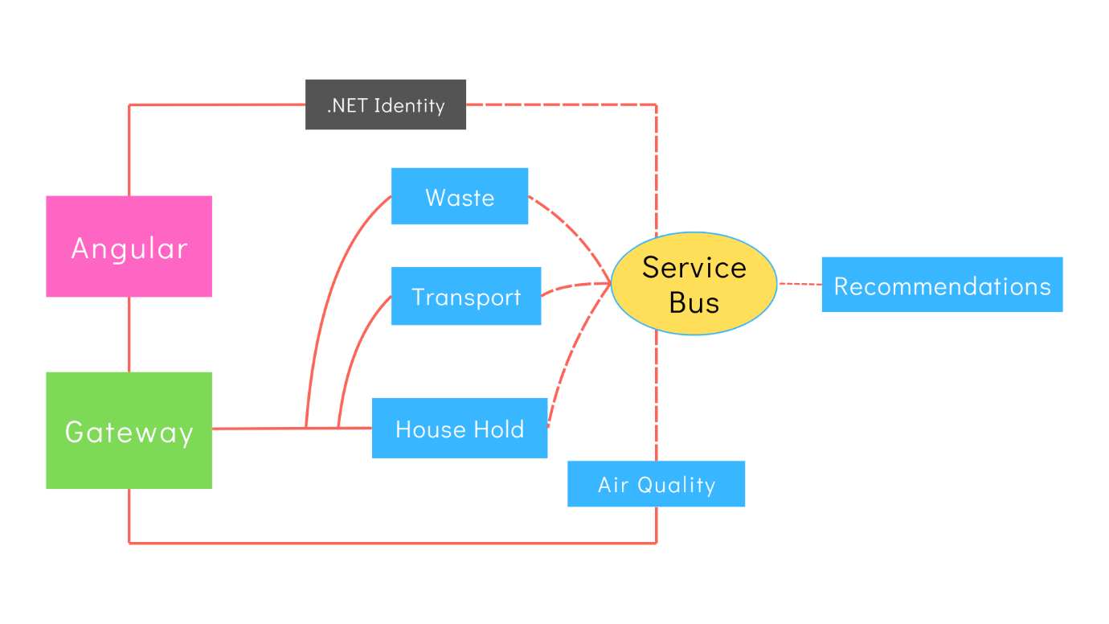

**November 5th, 2024**

**Agenda:**

* Prepare Prototype. (on Paper)

Our team created a preliminary UI prototype on paper for the EcoLife platform. This paper prototype includes essential screens and navigation flows, aligning with the core features planned for EcoLife: Home, About, Calculator, Air Quality, Login, and Sign Up. The purpose of this initial UI draft is to visually map out user interactions and assess the layout and functionality of each screen. We prioritized ease of navigation and accessibility, ensuring that the UI design would be intuitive and user-friendly. This session allowed us to gather early feedback and identify any potential layout adjustments before moving into digital wireframing. This prototype serves as a foundation for refining the EcoLife user experience, making it a crucial step in our design process.

**November 6th, 2024**

**Agenda:**

* Finalized UML Diagrams

Database Diagram:

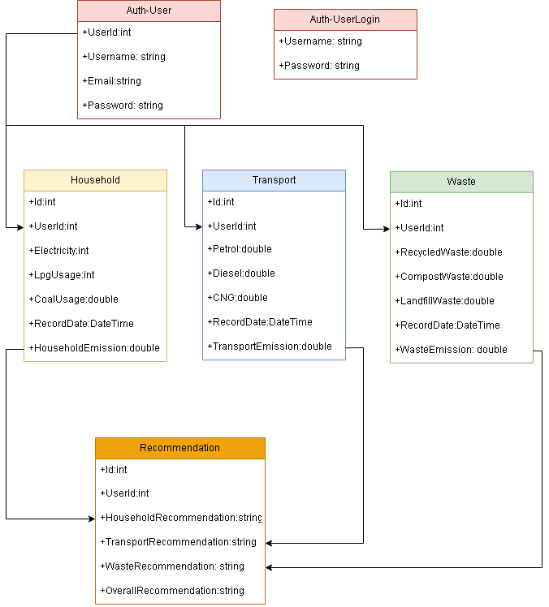

Activity Diagram:

System Architecture:

**November 7th, 2024**

**Agenda:**

* Prepared Documentation